**LAB 2**

**Terraform AWS provide and IAM user setting**

**Creating a new IAM user for CLI.**

**STEP 1: Create a new use by going in services > IAM > create a new user.**

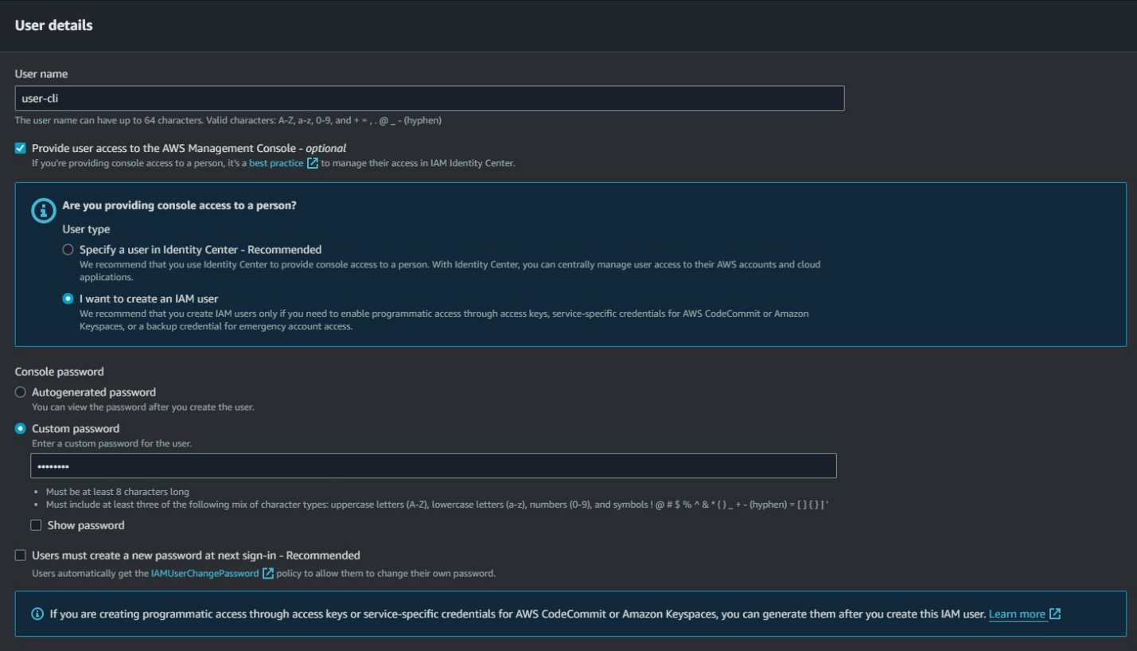

**STEP 2: Give the administration access to the user.**

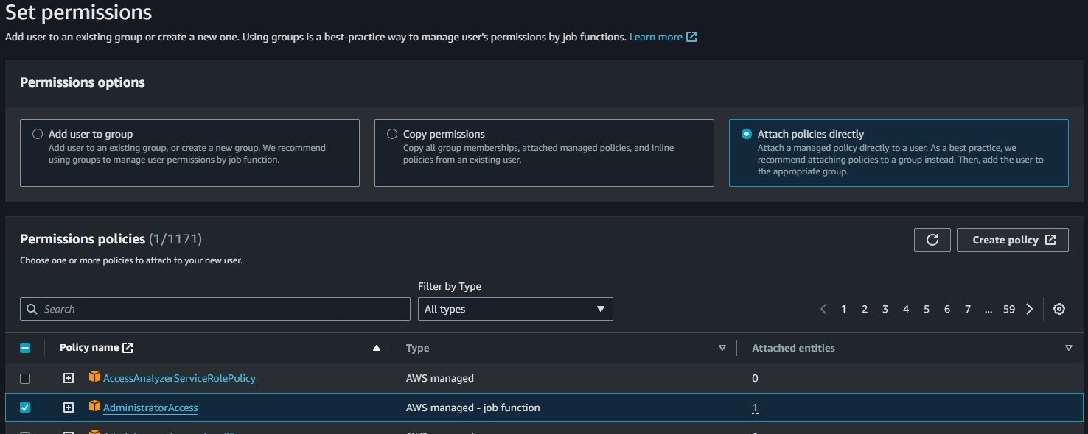

**STEP 3: Generate the access and security key under the security credentials , select the CLI as use case and give confirmation then click on next.**

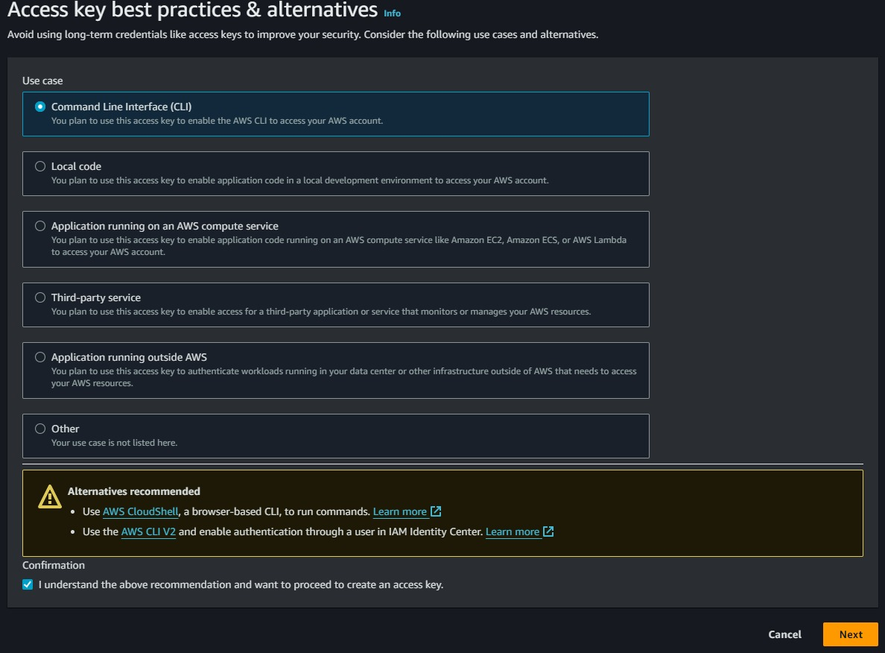

**STEP 4: Save the access and security key under the security credentials which will be used later to connect with terraform.**

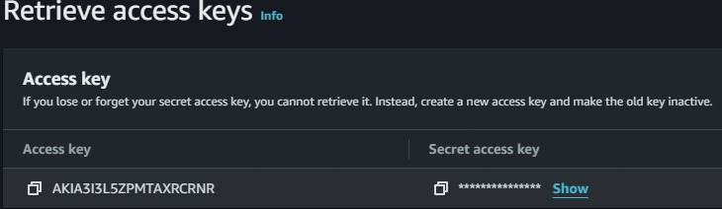

**Configuring terraform**

**STEP 1: Create a new Directory.**



**STEP 2: Create terraform configuration file (main.tf)**

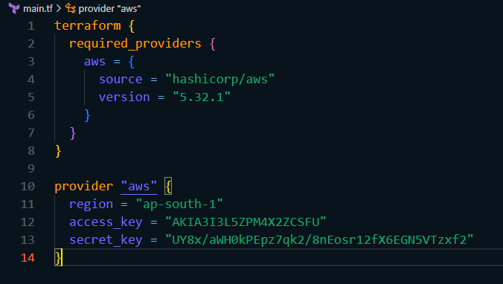

**STEP 3: Initialize terraform using ‘terraform init’ command.**

